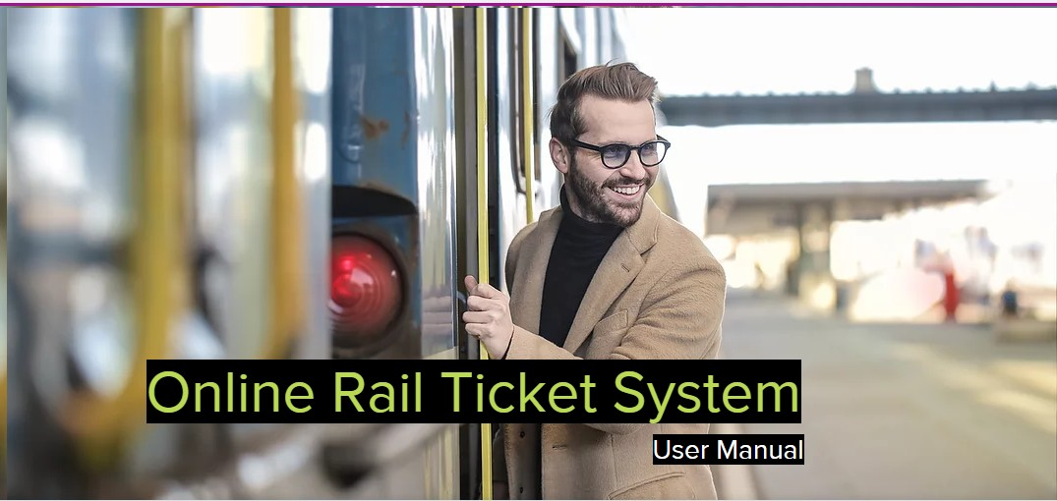

**Submitted to**

Md Shohel Arman

Lecturer at Daffodil International University

Mirpur road,Dhaka.

Department : Software Engineering

**Submitted by**

Md Ashraful Hossen Thusar

Id : 171-35-1908

Department : SWE

Subject : Documentation of Software engineering

**Home page:**

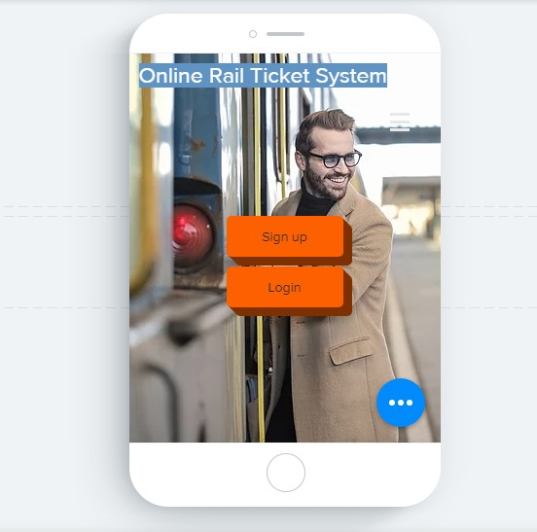

Here, this is my project **user manual** and I am going to descrive the project with users by using the project **UI** design screenshot. First of all, that is the Home/Starting page of my project. Where User can log into the application, in the other hand for the first time user , they can sign up in this section.

**Sign Up :**

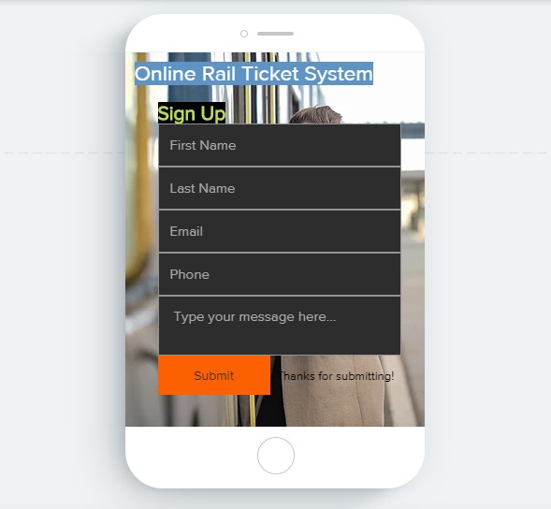

When the first time user try to sign up in this application this app give them a surface to sign up by providing some information. Like as “Name”, “Email”, “Phone Number”. They have to submit all these things and after verification they will get permission to enter this application by the Authority.

**Verification:**

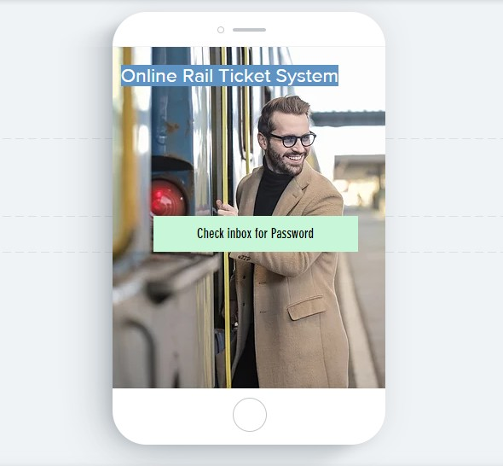

In this phase, Authority will give User a password to get access to log in this application. That password will send to User Email. By this Authority can be sure about there real email or actually there real identity.

**Login:**

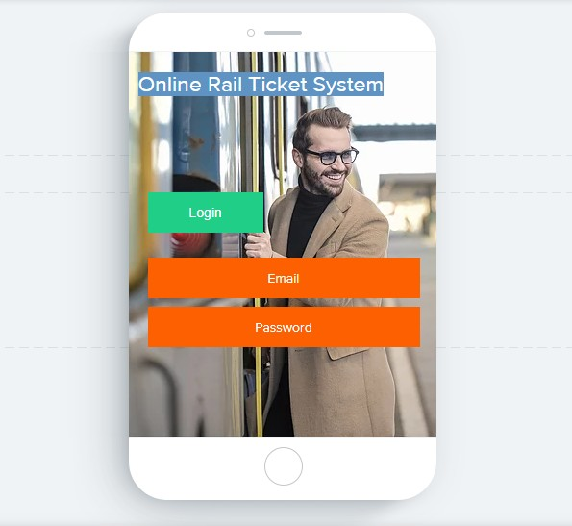

When User will get the password, they will be ready to Use this Application.

But, they have to provide their Email and password in this Stage.

**Profile:**

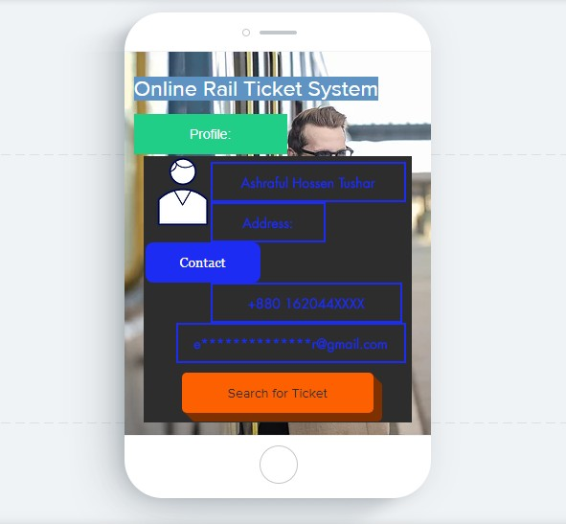

After Login, User can see their own personal Profile and they will be allow to search Train tickets.

**Travel Details:**

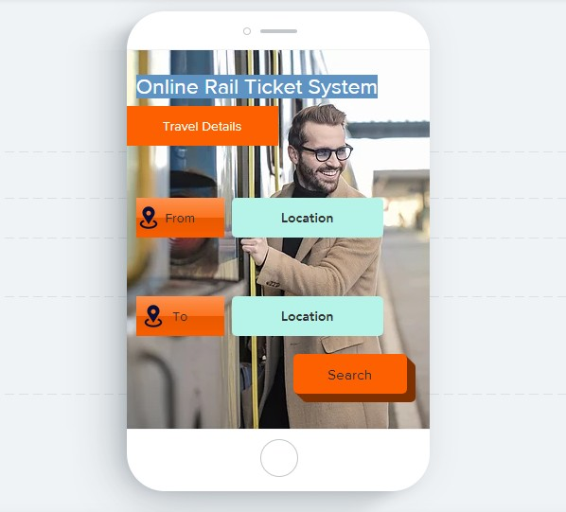

For Searching the train Ticket, they have to Enter the details of travel. From where to where they want to travel and have to click Search button.

**Result of Search:**

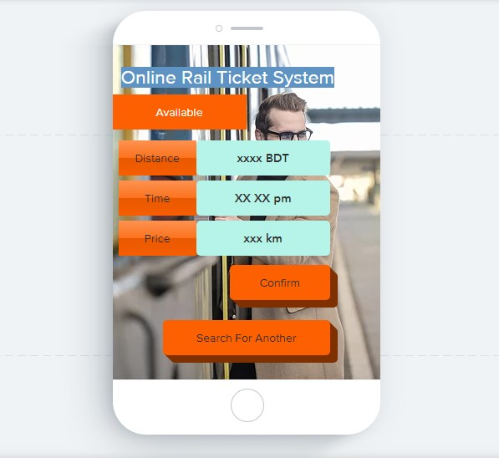

By considering the travel information if tickets are available, this application will show the result as available. And for Useful to user it will also show the distance, train schedule, and the price of the ticket. If customer want then they can confirm ticket here other wise they also can search other train ticket.

**Result of Search:**

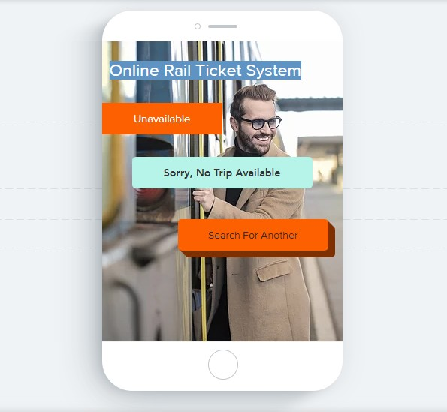

But If,

Application don’t find any Available trip by considering the user input. Then it Provide a Messege “Sorry, No Trip Available”.

After that, Customer will Search for Another tickets Again.

**Payment:**

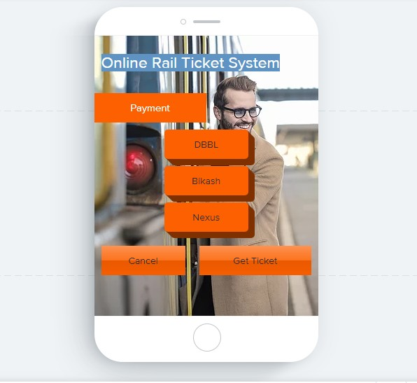

If in the previous stage customer confirm their tickets, then the system show the payment method. In this section, customer can pay the ticket price by using DBBL/Bikash/Nexus. In the other hand they can also cancel their ticket in thish section.

Here the cancel button link with customer profile. By clicking the cancel Button they will go their profile again and have to do all the things again.

**Get Ticket:**

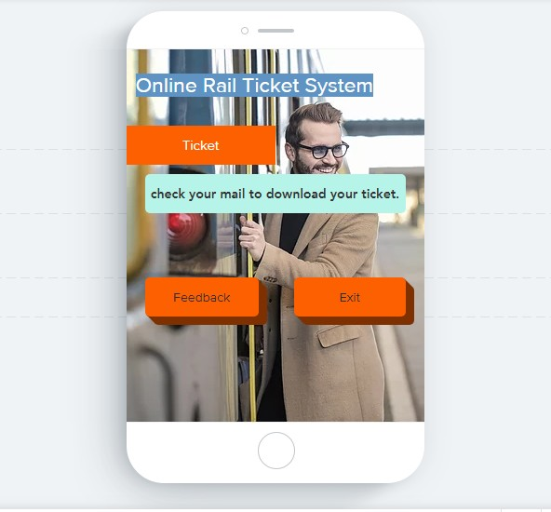

In the Payment section If they paid there ticket price and click the “Get ticket” button. Then they will get a mail which provide their train ticket by attaching a PDF file.

In this section, customer will be able to go out from the application by clicking the Exit button and if they want, they also give us a review by clicking the Feedback button.

**Feedback:**

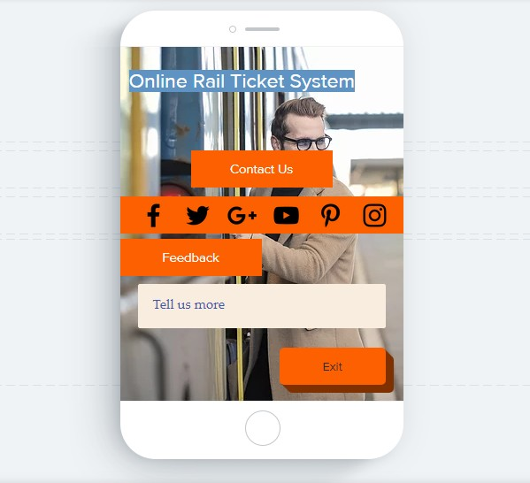

If customer click the Feedback button, they will Find some social websites link to contact with us and they can give us their important review to improve the project as well.

**Thank you**